|  |  |
| --- | --- |
| Icon  Description automatically generated  Digi Nodes  A DigiByte node crawler | Abstract  DigiNodes is a node viewer where anyone can check the number of peers that forms the DigiByte Network.  Renzo Diaz  Blockchain developer  Mark McNiel  Product owner  DigiByte Alliance  Sponsor |

Contents

Chapter 1: Project information 2

Abstract 2

Team 2

Purpose and Goals 2

Description 2

Physical architecture 3

Logical architecture 4

Project modules 4

Requirements 5

Functional requirements 5

Nonfunctional requirements 5

Comparable products 5

Premises and restrictions 6

Tasks schedule 6

Chapter 2: Deployment information 7

Server specifications 7

Execution environment 7

Recommended providers 7

Chapter 3: Cost estimations 8

Development cost 8

Scheduled payments 8

Maintenance cost 8

Change control 9

# Chapter 1: Project information

## Abstract

DigiNodes is a node viewer where anyone can check the number of peers that forms the DigiByte Network. It constantly scans the network to find new nodes and check the status of already know peers.

The website provides some reports for better understanding of the network and for public knowledge. Also, there will have a public widget that can be embedded on third party websites.

## Team

The **DigiByte Alliance** has commissioned this project to the developer **Renzo Diaz** and the intermediary, and the product owner is **Mark McNiel**.

|  |  |  |
| --- | --- | --- |
| Name | Email | Role |
| Renzo Diaz | renzo.diaz@remadi.net | Developer |
| Mark McNiel | mark@aroundtheblock.us | Product Owner |
| DigiByte Alliance | - | Sponsor |

## Purpose and Goals

The **DigiByte Alliance** has commissioned this project in order to have a public reliable source for people to review the actual state of the **DigiByte Network**. Also, to have a trusted source for network analytics and comparison with other cryptocurrencies.

There are 3 main goals to be achieved at the end of the project:

* Have a list of all the public and active DigiByte nodes
* Know the predominant subversion of the **DigiByte Core** in the network.
* Provide a public widget/API for third party websites.

## Description

The DigiNodes software is a node crawler for the DigiByte Network. Is considered as a web spider that retrieve data from DigiByte peers and maps the state of the network.

### Physical architecture

The physical architecture which describes the hardware topology is represented in the next diagram:

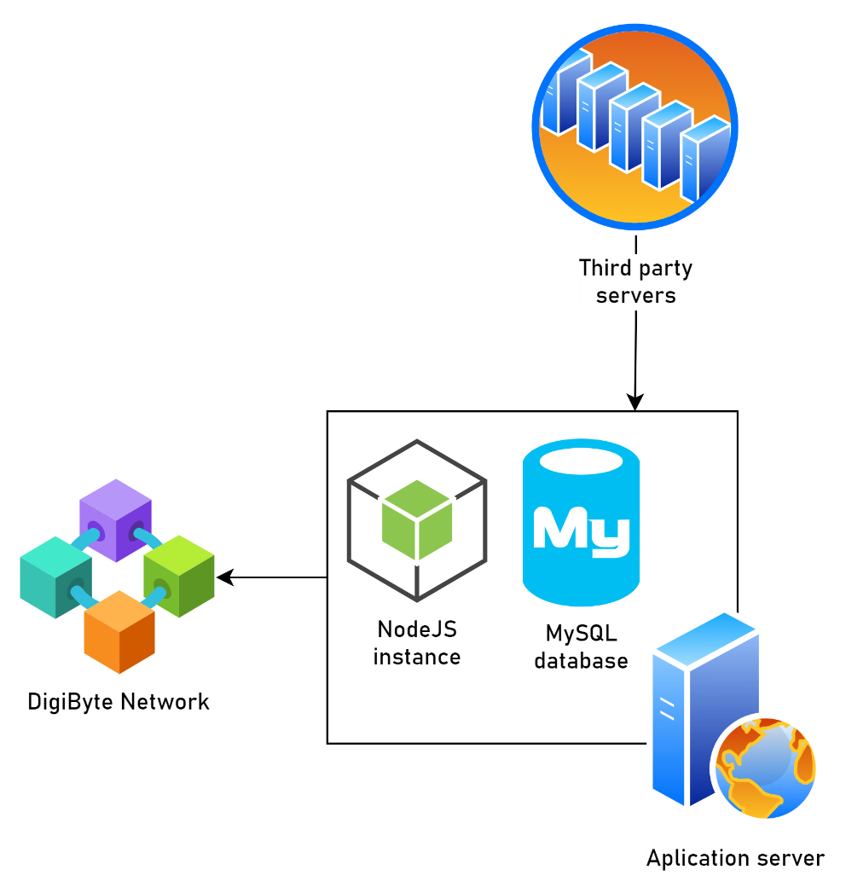

It consists in a central application server that host a NodeJS instance and a MySQL database that connects via TCP/IP protocol to the DigiByte Network through its peers. Additionally, it provides endpoints for third party servers to connect via a public API.

### Logical architecture

The logical architecture which describes the software internals is represented in the next diagram:

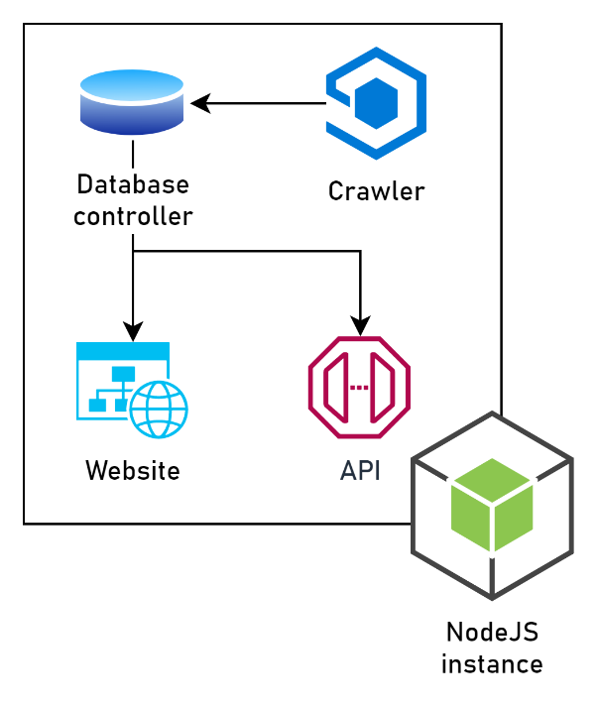

The crawler is a module of the project and scans the network while saving the retrieved data using the database controller. There are two consulting endpoints for the information, the website, and an API rest.

The website is for human interactions and the API is intended to be consumed by third party services and a widget.

### Project modules

#### Node crawler

A piece of code designed to constantly ping a list of IPs to check the presence of a **DigiByte Node**. If a peer is detected the crawler will proceed to retrieve all the IPs that are known by it. It’s able to read and write into a relational database and keep track of already known peers re-scanning them time to time.

#### Website

User friendly interface to visualize the data retrieve by the crawler. It contains some useful diagrams to represent the information for better understanding. It’s only capable to write into the database through a node tester.

#### Public API

A JSON format http endpoint that contains the data retrieve by the crawler. Each of the reports showed on the website has their equivalent calls in this API. It’s only capable to write into the database by registering the calls made by third party services.

## Requirements

Characteristics that the project must fulfill.

### Functional requirements

|  |  |  |
| --- | --- | --- |
| ID | Descriptions | Type |
| FR01 | Ping IP address and port to check a DigiByte node | Back-end |
| FR02 | Retrieve version and subversion of a DigiByte node | Back-end |
| FR03 | Save the DigiByte nodes in a table | Back-end |
| FR04 | Check the status of a known peer | Back-end |
| FR05 | Query the network information in an API | Back-end |
| FR06 | Show the number of active nodes | Front-end |
| FR07 | Show the number of active nodes per subversion | Front-end |
| FR08 | Show the peers in a world map | Front-end |
| FR09 | Query a single DigiByte Node | Front-end |
| FR10 | Have a public widget with the number of active nodes | Front-end |

### Nonfunctional requirements

|  |  |  |
| --- | --- | --- |
| ID | Descriptions | Type |
| NFR01 | Back-end developed in NodeJS | Back-end |
| NFR02 | Have the nodes scanned every 24h | Back-end |
| NFR03 | Bootstrap like UI front-end | Front-end |

## Comparable products

Chainz crypto explorer

Bitnodes.io

## Premises and restrictions

This project will be developed under the premise that the sponsor will maintain the service created during its expected lifetime. Is under the **DigiByte Alliance** responsibility to provide the servers and the environment for the execution of the DigiNodes software. Also, the future maintenance costs such as server expenses and API keys provided by third party services to fulfill the functional requirements. And finally, the deployment of the software and configuration of the server has to be provided by the sponsor.

The only time restriction specified for this project is that the crawler and some requirements of the website (specified in the Gant’s diagram) must be completed in late June 2022.

## Tasks schedule



# Chapter 2: Deployment information

## Server specifications

The application server must fulfill some basic characteristics in order to provide a correct execution environment for the DigiNodes software:

|  |  |  |  |
| --- | --- | --- | --- |
| Feature | Basic | Recommended | Best |
| Storage | 3GB of SSD | 5GB of SSD | 15GB of SSD |
| CPU Cores | 2 Cores | 3 Cores | 3 Cores |
| RAM | 2GB | 3GB | 5GB |
| N of Processes | 40 | 60 | 80 |
| Inodes | 250’000 | 250’000 | 250’000 |
| SSL Creation | Yes | Yes | Yes |
| DNS management | Yes | Yes | Yes |
| Bandwidth | unlimited | unlimited | unlimited |

## Execution environment

The software required to run the DigiNodes software:

* NodeJS v16.14.2 or more
* MySQL v8.0.29 or more

## Recommended providers

Providers for web infrastructure (not sponsored) if the **DigiByte Alliance** does not have the require servers:

* Fastcomet: <https://www.fastcomet.com/>
* Chemicloud: <https://chemicloud.com/>

# Chapter 3: Cost estimations

## Development cost

Based on the requirements listed earlier and an effort estimation showed in the timeframe specified on the tasks schedule the development costs of the project will be 1’000 USD and will be paid in four separate payments of 250 USD.

The amount will be paid in DigiByte (DGB) using the last conversion rate at the time of the payment.

### Scheduled payments

|  |  |  |  |
| --- | --- | --- | --- |
| Date (UTC) | Amount (DGB) | Address | TXID |
| May 26th 2022 | 22’064.98225534 | dgb1qh6wewyld4yguggxa96n4n3w82ml60p945d7hjc | 096cd1c6fe11a7e99b03ac8803035c8aac46b1c963c4ee9b95ef85c0303b818e |
| June 3rd 2022 | 22’879.12773783 | dgb1qh6wewyld4yguggxa96n4n3w82ml60p945d7hjc | 657fb4783fddfced7058b1a83bd088fa56369e52afef3dc645d56884ee3ab4cc |
| June 22nd 2022 |  |  |  |
| July 4th 2022 |  |  |  |

## Maintenance cost

There is no extra cost for the project (except if the sponsor has contracted a web provider)

# Change control

Committed changes in the document:

|  |  |  |
| --- | --- | --- |
| Date | Approved by | Changes |
| June 5th 2022 | Renzo Diaz | Document creation |
|  |  |  |
|  |  |  |
|  |  |  |
|  |  |  |